

UNDERGRADUATE PROJECT REPORT

|  |  |
| --- | --- |
| **Project Title:** | **Incorporating Separable CNN in Inception Network with Residual Learning for Enhanced Breast Cancer Classification** |
| **Surname:** | **Chen** |
| **First Name:** | **ZiXuan** |
| **Student Number:** | **202018010209** |
| **Supervisor Name:** | **Dr Grace Ugochi Nneji** |
| **Module Code:** | **CHC 6096** |
| **Module Name:** | **Project** |
| **Date Submitted:** | **May 5, 2023** |

# **Table of Contents**

Declaration i

Acknowledgment ii

Table of Contents iii

List of Figure v

List of Table vi

Abstract vii

Abbreviations viii

Glossary ix

Chapter 1 Introduction 1

1.1 Background 1

1.1.1 Inception Network 1

1.1.2 ResNet 2

1.1.3 VGG-16 3

1.2 Aim 3

1.3 Objectives 3

1.4 Project Overview 4

1.4.1 Scope 4

1.4.2 Audience 4

Chapter 2 Background Review 6

Chapter 3 Methodology 8

3.1 Approach 8

3.1.1 Simple GoogleNet 8

3.1.2 CNN_ResNet Block 9

3.1.3 CBAM Attention Block: 11

3.1.4 He-normal 12

3.1.5 Proposed Model Structure 12

3.2 Technology 13

3.3 Testing and Evaluation Plan 14

3.3.1 Data Testing Strategy 14

3.3.2 Model Testing/Evaluation Strategy: 15

3.3.3 Pipeline Testing: 15

3.4 Project Version Management 15

Chapter 4 Implementation and Results 16

4.1 Implementation 16

4.1.1 Dataset 16

4.1.2 Model Iteration 17

4.2 Results of Final Model Training 19

4.3 Related work compares 27

4.4 Model Explainability 28

4.4 UI design 32

Chapter 5 Professional Issues 34

5.1 Project Management 34

5.1.1 Activities 34

5.1.2 Schedule 36

5.1.3 Project Data Management 36

5.1.4 Project Deliverables 37

5.2 Risk Analysis 37

5.3 Professional Issues 38

5.3.1 Legal Issues 38

5.3.2 Social Issues 38

5.3.3 Ethical Issues 39

5.3.4 Environmental Issues 39

Chapter 6 Conclusion 40

6.1 What Was Achieved: 40

6.2 Limitations: 40

6.3 Potential Future Work: 41

References 43

# **List of Figure**

Figure 1: Samples of GoogleNet [22] 2

Figure 2: Classic ResNet block [23] 2

Figure 3: Simple GoogleNet 9

Figure 4: CNN_ResNet Block 10

Figure 5: Overview of CBAM block [9] 11

Figure 6: Proposed Model Structure 13

Figure 7: Dataset percentage 16

Figure 8: Performance for first version model 17

Figure 9: Performance for second version model 17

Figure 10: Performance for third version model 18

Figure 11: Performance for second version model 18

Figure 12: Accuracy (0.952) and Loss (0.11) for Proposed Model 20

Figure 13： Confusin matrix for Proposed Model 21

Figure 14: Distribution of Predicted Probabilities 22

Figure 15: Receiver Operating Characteristic 23

Figure 16: Precision-Recall Curve 25

Figure 17： Grad-CAM samples 29

Figure 18: Grad-CAM in different depth (from left to right are shallowest level to deepest level) 30

Figure 19： UI interface Homepage 32

Figure 20： UI interface Result show 33

Figure 21: The project schedule Gantt 36

# **List of Table**

Table 1: Model findings and possible results by numerous researchers for the breast cancer classification 6

Table 2: The technologies of the project 13

Table 3. Compare with classic models 22

Table 4. Compare with models from different research 23

Table 5： Activities of objects 32

Table 6： Management methods of Data 33

Table 7: The Risk 33

# **Abstract**

Breast cancer is a significant health concern worldwide, necessitating timely and accurate diagnosis for effective treatment. This project aims to address the challenges associated with breast cancer diagnosis by proposing an innovative deep learning model leveraging VGG16, Inception, ResNet, and an attention mechanism. The primary objective is to develop a model that outperforms traditional methods in diagnosing cancer from histopathological images. The project's objectives include data collection and preprocessing using the BreaKHis_400X dataset from Kaggle, designing an optimal model architecture through comparative analysis and integration of ResNet, VGG16, and Inceptionv3, training the model with various optimizers and epochs, and evaluating its performance using accuracy, precision, recall, and F1 score metrics. The proposed model achieves impressive performance metrics, including an accuracy of 96.4%, sensitivity of 0.96, specificity of 0.97, precision (Pc) of 0.974, F1-Score of 0.971, and recall of 0.968. These metrics highlight the model's efficacy in accurately diagnosing breast cancer from histopathological images. Comparative analysis with existing models will further highlight the proposed model's advantages and potential improvements, while interpretability efforts will elucidate its workings using mathematical formulations. The outcomes of this project aim to elevate diagnostic accuracy, improve treatment outcomes, and ultimately safeguard women's well-being by reducing the burden of breast cancer on individuals and healthcare systems globally. The resulting report will provide comprehensive insights into the data sources, methodologies, experimental results, and the proposed model's efficacy in breast cancer diagnosis.

***Keywords: Breast cancer, deep learning, VGG16, Inception, ResNet, attention mechanism, data preprocessing,*** ***BreaKHis 400X,***

# **Introduction**

## **Background**

Breast cancer is a complex disease characterized by the rapid and uncontrolled proliferation of breast cells, leading to the formation of abnormal growths or tumors. These tumors commonly arise within the breast's milk-producing ducts, a condition known as invasive ductal carcinoma [1] – [2]. The impact of breast cancer on women's health cannot be overstated, making early detection crucial for successful treatment outcomes [3].

Timely diagnosis significantly improves the chances of successful treatment, allowing healthcare providers to implement appropriate interventions and therapies at an early stage. However, in regions with limited per capita medical resources, accessing timely and accurate diagnostic services can be challenging, leading to delays in treatment initiation.

To address these challenges, leveraging advanced technologies such as convolutional neural networks (CNNs) given a promising solution.

Integrating CNNs into the diagnostic workflow offers several advantages. Firstly, it streamlines the diagnostic process, reducing the time and effort required for manual image analysis. Secondly, CNNs can assist in identifying subtle or early-stage breast cancer manifestations that may be missed during conventional screenings. Thirdly, this technology-driven approach helps mitigate the impact of limited medical resources by optimizing the use of available healthcare infrastructure and expertise.

By embracing convolutional neural networks for breast cancer detection, healthcare systems can elevate diagnostic accuracy, improve treatment outcomes, and ultimately safeguard women's well-being. This innovative approach not only enhances healthcare standards but also contributes to reducing the burden of breast cancer on individuals and healthcare systems globally.

### **Inception Network**

Before describing the project, it’s necessary to introduce the concepts of main technology used in the research. Such as the Inception Network, which also known as GoogLeNet. It is a deep learning architecture proposed by Google in 2014. Its design aims to address the issues of excessive parameters and computational complexity in traditional Convolutional Neural Networks (CNNs). Compared to traditional network structures, the Inception Network adopts a modular design called the "Inception Module." This modular structure allows the network to increase depth and width without adding too many parameters, thereby improving the model's performance and efficiency.

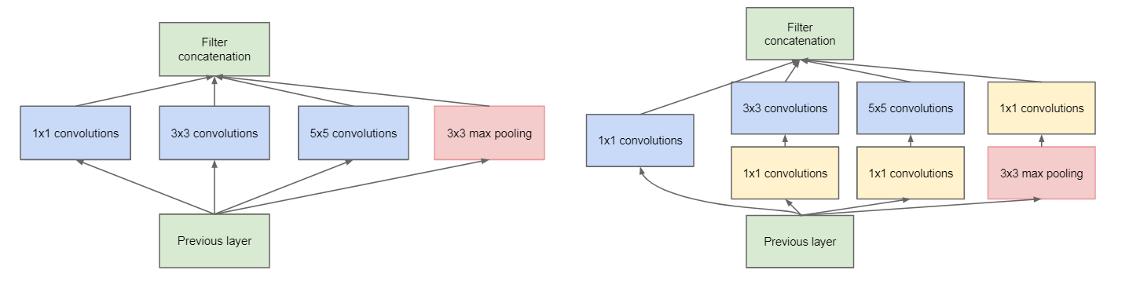

Figure 1: Samples of GoogleNet [22]

A key feature of the Inception Network is the use of multi-scale convolution operations, different convolution kernels, combined with pooling operations and concatenation to integrate feature maps of different scales. This design enables the network to capture information from different scales simultaneously, enhancing the model's ability to represent complex data.

### **ResNet**

ResNet, short for Residual Network, is a deep residual network structure proposed by Microsoft to address the issues of gradient vanishing and training difficulties in deep neural networks. Its core idea is the introduction of residual connections, which allow the network to learn residual mappings, making it easier to train very deep networks.

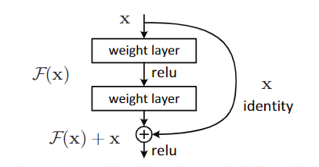

Figure 2: Classic ResNet block [23]

The formula for a ResNet residual block can be expressed as**: $y=x+F(x, W)$**

The x is the input, y is the output, F(x, W) represents the residual mapping, and W denotes the weight parameters within the residual block. Through such residual connections, the network can remember the information of the original layer, thus avoiding the gradient vanishing problem encountered in traditional deep learning networks.

### **VGG-16**

VGG16 is a deep convolutional neural network architecture proposed by the Visual Graphics Group (VGG) at the University of Oxford. It is widely recognized for its simplicity and effectiveness in image classification tasks. The "16" in VGG16 refers to the total number of weight layers in the network, including 13 convolutional layers and 3 fully connected layers.

One of the key characteristics of VGG16 is its use of small 3x3 convolutional filters throughout the network, with a stride of 1 and same padding. This design choice allows the network to learn complex features while keeping the number of parameters relatively low compared to other architectures. Additionally, VGG16 uses max-pooling layers after every two convolutional layers to downsample the spatial dimensions of the feature maps.

Although VGG16 has been surpassed by more complex architectures like ResNet and Inception in terms of performance on certain tasks, it remains a popular choice for image recognition and transfer learning due to its straightforward design and ease of implementation.

## **Aim**

Organizational pathology images represent a valuable resource for early detection breast cancer. However, the complexity of these images poses challenges to accurate diagnosis. This project aims to propose an innovative deep learning model to address these challenges, enhancing the accuracy and efficiency of breast cancer diagnosis and advancing the field of medical image analysis.

## **Objectives**

The primary objective of this project is to develop a deep learning model that integrates VGG16, Inception, ResNet, and an attention mechanism to outperform traditional models in diagnosing cancer from histopathological images. To achieve this overarching goal, this project has established the following specific objectives:

* Data Collection and Preprocessing: To facilitate comparisons with existing research, this research plan to use the widely employed breast cancer dataset, BreaKHis_400X, available on the Kaggle website.
* Model Architecture Design: To design the optimal structure, the method involves three steps: conducting a comparative analysis of individual CNN models (ResNet, VGG16, and Inceptionv3), arranging and infusing these models for evaluating their respective effects (accuracy, precision, recall, and F1 score), and integrating the best-performing structure of the three models with additional fine-tuning.
* Model Training: Train the designed deep learning model using the prepared dataset. Try the different optimizer and epoch number.
* Model Evaluation: Assess the model's performance by evaluating its ability to accurately classify breast tissue images as malignant or benign. Utilize various metrics such as accuracy, precision, recall, and F1 score to quantify the model's diagnostic capabilities.
* Comparative Analysis: Conduct a comparative analysis with existing cancer diagnostic models and techniques, emphasizing the advantages and potential improvements of the proposed model.
* Interpretability: Attempt to elucidate the model's workings and express them using mathematical formulas.
* Documentation and Reporting: Prepare a report including data sources, methodologies, experimental results.

## **Project Overview**

### **Scope**

The purpose of this study is to develop a deep learning framework, integrating VGG, Inception, Resnet and attention mechanisms, for the accurate diagnosis of breast cancer using histopathological images. The primary objective is to improve the accuracy and efficiency of breast cancer diagnosis.

The significances of this study are as follows:

* Advance early detection and diagnosis which improving patient outcomes and reducing the burden of this disease.
* Provide the medical image domain an effective and efficient diagnostic tool.
* Provide valuable insights for researchers and practitioners working on related projects.
* Foster cross-disciplinary collaboration in computer vision and medical imaging.
* Provide a low-cost, high-coverage diagnostic option to address healthcare accessibility issues, aligning with public healthcare initiatives.

### **Audience**

This project will benefit the following stakeholders:

* Patients: Patients will benefit from more accurate and timely breast cancer diagnoses, leading to earlier treatment, better survival rates, and improved quality of life.
* Medical Professionals and Healthcare Institutions: Healthcare practitioners, including radiologists and oncologists, will have access to a more precise diagnostic tool, aiding in their decision-making and patient care. Hospitals and healthcare facilities can improve their diagnostic accuracy and efficiency, ultimately enhancing patient care and outcomes.
* Government: Government can provide accessible and affordable healthcare services which will be cost-effective and high-coverage diagnostic option.
* Public: The general public will benefit from the broader public health implications, including early detection, reduced healthcare costs, and improved healthcare equity.
* Researchers: The findings will contribute to the academic and scientific knowledge in the field of artificial intelligence, computer vision, and medical image analysis, benefiting researchers and practitioners in these areas.

# **Background Review**

This section will discuss different researches carried out by different researchers based on breast classification using deep neural networks.

Karatayev et al. [4] focused on implementing a convolutional neural network (CNN) model for accurate invasive ductal carcinomas (IDC) classification in breast cancer histopathology images. The proposed model achieves an accuracy of 92% for image classification, outperforming the baseline CancerNet model with an accuracy of 86%.

Another authors, Samanta et al. [5] proposed a novel deep convolutional neural network (CNN) model called BCI-Net for breast cancer classification. The Mish activation function is applied in the model to enhance performance and training dynamics. The model achieves an average accuracy of 98.70% using hold-out validation and 97.49% overall average accuracy with a standard deviation of 1.14% using five-fold cross-validation. The paper also discusses the methodology for breast cancer classification, including data pre-processing, feature extraction, model training, and prediction on new images.

More so, M. Ronald et al. [6] suggested a model named iSPLInception, an Inception-ResNet deep learning architecture for human activity recognition. The paper presents a novel approach to improving predictive accuracy for devices with limited computational resources, making it a valuable resource for researchers and practitioners. In a study, Parvin et al. [7] compared various CNN architectures for breast cancer histopathological image classification. The models examined were LeNet-5, AlexNet, VGG-16, ResNet-50, and Inception-v1, using the BreaKHis dataset for benign and malignant tumor binary classification. Evaluation metrics, including accuracy, AUC, precision, recall, and F1-score, were employed. Inception-v1 achieved the highest accuracy (89%, 92%, 94%, and 90% at different magnifications) and outperformed other models in all metrics, highlighting its relevance in breast cancer identification. Table 1 summarizes the different researches analyzed by numerous researchers and their possible results.

A. Gautam and S. K. Singh [15] introduces various methodologies for identifying breast cancer and focuses on a new approach using deep learning architectures specifically for classifying breast cancer from histopathology images. The study compares several deep learning models, including DenseNet121, DenseNet169, DenseNet201, EfficientNetB0, EfficientNetB5, EfficientNetV2B0, and EfficientNetV2S, which have fewer trainable parameters compared to previously studied models like AlexNet, VGG, and ResNet. The experiments were conducted using the BreakHis histopathology dataset, including images of resolutions 40X, 100X, 200X, and 400X for both benign and malignant cancer cases. The approach involved setting uniform parameters for training and testing across all architectures and then comparing their performance to determine the most suitable model for breast cancer classification. In essence, the study explores the efficacy of various deep learning models with reduced trainable parameters in accurately classifying breast cancer from histopathology images, providing valuable insights for future research and clinical applications.

|  |  |  |
| --- | --- | --- |
| **Researchers** | **Techniques** | **Performance** |
| Parvin et al. [7] | LeNet-5 | Accuracy≈68% |
| Alexnet | Accuracy≈89% |
| VGG 16 | Accuracy≈83% |
| ResNet-50 | Accuracy≈66% |
| Inception-v1 | Accuracy=90% |
| Karatayev et al. [4] | Invasive Ductal Carcinomas (IDC) | Accuracy=92% |
| Samanta et al. [5] | BCI-Net | Accuracy=97% |
| A. Gautam et al. [15] | DenseNet121 | Accuracy=66.96% |
| EfficientNetB5 | Accuracy=66.83% |

Table 1: Model findings and possible results by numerous researchers for the breast cancer classification

# **Methodology**

## **Approach**

### **Simple GoogleNet**

This block mainly includes two Inception structures, each aimed at enhancing feature extraction and promoting learning within the neural network. Each Inception architecture is carefully crafted by four different branches, each with a specific purpose for extracting and processing information.

The first branch in each Inception structure uses (1,1) convolutional kernels, which are very suitable for capturing fine-grained details and preserving spatial information. This branch serves as the foundational element, facilitating the initial processing of input data.

The second branch combines (1,1) and (3,3) convolution kernels. The strategic choice of this configuration is to capture both local and more global functionality simultaneously. (1,1) kernels help with dimensionality reduction, while (3,3) kernels excel at capturing spatial relationships in the input.

The third branch uses (1,1) and (5,5) convolution kernels. This combination is beneficial for capturing large-scale patterns and structures in the data. The (5,5) nucleus with a larger receptive field can detect complex patterns that may span multiple smaller regions.

The fourth branch uses Maxpooling, followed by (1,1) convolution kernels. Maxpooling is used to downsample the input, preserving basic features while reducing computational complexity. The subsequent (1,1) convolution operation further refines these features, preparing them for integration into the final cascaded output.

The concatenation of the outputs of all four branches in each Inception structure creates a rich and comprehensive feature representation. The diversity of this feature extraction technique enhances the model's ability to learn complex patterns and relationships in data, making a significant contribution to its overall performance and effectiveness.

Those Inception structures with different branches and convolutional kernels play a crucial role in capturing multi-scale features, promoting efficient information processing, and ultimately improving the accuracy and robustness of the model's prediction capabilities [19]. Figure 1 provides an in-depth overview of this complex and powerful architecture design.Each two inception structures can be instantiated with different number of filters. And an overview of this structure is illustrated in Figure 1.

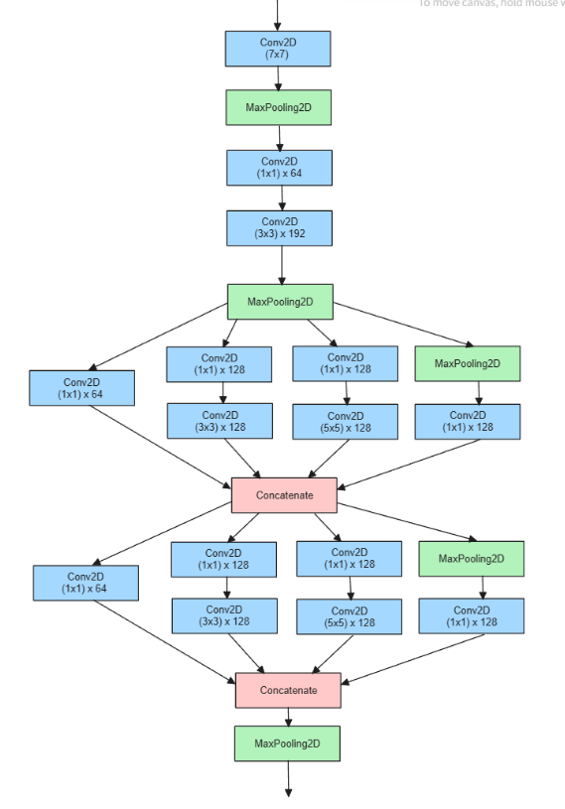

Figure 3: Simple GoogleNet

### **CNN_ResNet Block**

The CNN_ResNet structure draws inspiration from the VGG architecture, incorporating a design philosophy that emphasizes the iterative combination of two (3,3) convolutional neural networks (CNNs) followed by a MaxPooling operation. This approach is characterized by a continuous increase in the number of filters, enabling the network to learn progressively complex features across multiple layers.

Moreover, this architecture introduces the concept of residual learning, a technique that has proven highly effective in addressing the problem of gradient vanishing. The residual block within this architecture is defined by the following formula:

$$yi=h\left(xi\right)+F(xi, Wi)$$

$$x\left(i+1\right)=f(yi)$$

Here $xi$ is represents the input of layer $i$, $yi$ is the output of layer $i$, $F(xi, Wi)$ is the residual function, $h(xi)$ is the mapping function to ensure the dimensions of $xi$ and $F$ are equal, and $f(yi)$ is the activation function [8]. This mechanism effectively addresses the issue of gradient vanishing.

This formulation allows the original convolutional kernel to directly integrate into the block's output as a residual, enabling the network to learn residual mappings instead of the complete transformation. By adding these residual mappings to the original inputs, the network can effectively bypass layers and learn more efficient representations, thereby mitigating the challenges associated with vanishing gradients.

In essence, the incorporation of residual learning within this architecture enhances the model's ability to train deeper networks by facilitating the flow of gradients during backpropagation [18]. This mechanism not only improves the overall training convergence but also contributes to the network's capacity to learn intricate features and achieve higher performance levels.

The block overview shows blow:

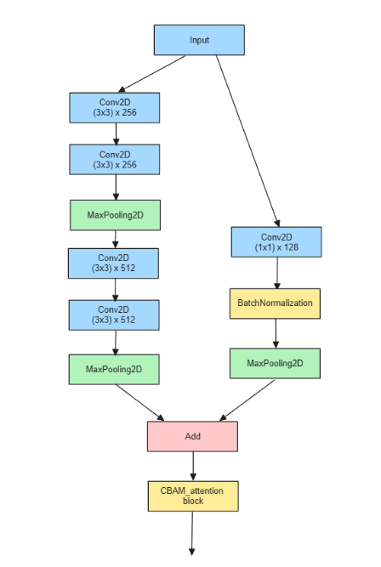

Figure 4: CNN_ResNet Block

### **CBAM Attention Block:**

CBAM, which stand for Convolutional Block Attention Module, represents a pivotal advancement in attention mechanisms within Convolutional Neural Networks (CNNs), aimed at augmenting their capacity to discern crucial features in images more efficiently. This module is structured around two fundamental components: the Channel Attention Module (CAM) and the Spatial Attention Module (SAM). The Channel Attention Module (CAM) focuses on learning feature weights across different channels within the network. By analyzing inter-channel relationships, CAM identifies which channels are most informative and allocates attention accordingly. This mechanism allows the network to prioritize relevant features while suppressing less important ones, thereby enhancing the quality of feature representation. On the other hand, the Spatial Attention Module (SAM) operates by learning feature weights in spatial dimensions. It analyzes spatial relationships within feature maps to identify important regions within an image. This allows the network to dynamically adjust its focus, directing attention to salient areas and ignoring irrelevant or noisy regions.

The synergy between CAM and SAM within the CBAM framework is crucial. The output of the CBAM module is computed by multiplying the outputs of CAM and SAM. This combined attention mechanism empowers CBAM to learn feature weights simultaneously in both channel and spatial dimensions. Consequently, the model becomes adept at capturing nuanced details, relevant structures, and contextually important regions within images. The holistic approach of CBAM, incorporating both channel and spatial attention mechanisms, leads to a more comprehensive understanding of image features. This not only improves the model's ability to extract important information but also aids in focusing on diverse aspects of the image, resulting in enhanced performance across various tasks such as object recognition, segmentation, and classification.

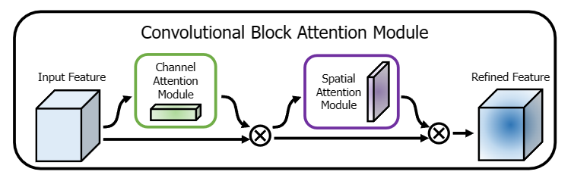

Figure 5: Overview of CBAM block [9]

### **He-normal**

"He-normal" is a weight initialization method, also known as "He initialization." In neural networks, weight initialization plays a crucial role in the training and performance of the model. The primary principle behind "He-normal" is to initialize the weights of a layer based on the number of inputs and outputs for that layer.

Specifically, the weights are initialized from a normal distribution with a mean of zero and a standard deviation of $sqrt\left(\frac{2}{n}\right)$ where n is the number of neurons in the previous layer.

In mathematical terms, the probability density function of the normal distribution is:

$$f\left(x; μ,σ\right)=\left(\frac{1}{sqrt\left(2pi*σ\right)}\right)e^{\frac{-{\left(x-μ\right)}^{2}}{2σ^{2}}}$$

In "He-normal" initialization, μ is 0 and σ is $sqrt\left(\frac{2}{n}\right)$. This ensures that the weights are initialized with zero mean while making the size of the weights relative to the input dimensions, helping to maintain appropriate variance.

The goal of this initialization method is to ensure that the variance of each layer's output remains roughly the same during forward propagation. This helps prevent issues such as vanishing or exploding gradients in deep networks, contributing to a more stable and effective training process.

### **Proposed Model Structure**

The proposed model architecture starts by branching the input data into two pathways. The first pathway processes the input data through a CNN_ResNet block, leveraging residual connections to combine classic convolutional layers and mitigate the vanishing gradient problem, thus enabling a deeper architecture. Following this initial processing, further refinement of features is performed using a CBAM block, which applies attention mechanisms on both channel and spatial dimensions to emphasize crucial local features in shallow data layers. This process is repeated with another set of CNN_ResNet and CBAM blocks, employing residual learning and directional attention to learn more abstract features and focus the model's output on overall data representation.

Simultaneously, the model's second pathway processes the input data through a simple GoogleNet path, employing different feature extraction techniques. Simple GoogleNet utilizes the Inception concept, allowing modules to handle multiple levels of features concurrently, enhancing the diversity of feature sets. The outputs of the sequentially processed (CNN_ResNet and CBAM blocks) and the parallel simple GoogleNet path are then concatenated. This step combines deep, detailed features with diversified, multi-scale features to create a comprehensive feature set.

After cascading the two pathways, the model applies dropout layers to prevent overfitting by randomly zeroing subsets of features, ensuring robustness against variations in input data. Next is global average pooling, which reduces each feature map to a single value by averaging, preserving essential information while reducing computational demands. Finally, the model utilizes dense layers to integrate all learned features into the final prediction or classification. This architecture not only enables effective deep learning through enhanced feature extraction and attention concentration but also incorporates mechanisms like dropout and global pooling to reduce overfitting and computational complexity, making it highly effective for complex recognition or classification tasks.

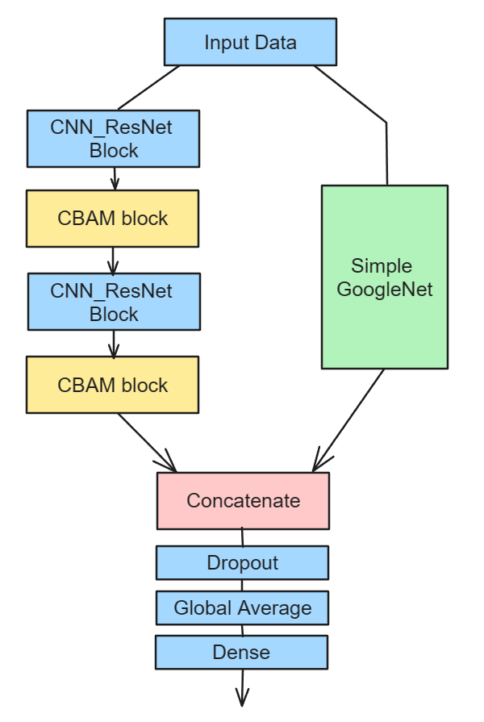

Figure 6: Proposed Model Structure

## **Technology**

The technology used in this research is displayed in Table 2.

|  |  |  |
| --- | --- | --- |
| Software | Operating system | Windows 10, 64bit |
| Framework | Tensorflow-gpu 2.7.0 |
| Python | 3.9.16 |
| Python Libraries | Numpy, keras, sklearn, matplotlib, OpenCV |
| Version management | Git repository |
| Hardware | CPU | 12th Gen Intel® Core™ i7-12700KF |
| GPU | NVIDIA GeForce RTX 3070 Ti |
| Memory | 32 GB |

Table 2: The technologies of the project

## **Testing and Evaluation Plan**

The project will systematically incorporate testing and evaluation throughout the development lifecycle. Below, will outline the comprehensive testing and evaluation plan:

### Data Testing Strategy

1. Data Quality Assessment: Evaluate the integrity, completeness, and consistency of the breast cancer dataset.

2. Data Preprocessing Testing: Verify the effectiveness of preprocessing techniques, such as separable convolutional neural network (CNN) and residual learning application, for optimal feature extraction.

3. Labeling Accuracy Testing: Assess the accuracy of labels assigned to instances in the breast cancer dataset, crucial for supervised learning tasks.

### Model Testing/Evaluation Strategy:

1. Training Set Evaluation: Assess the model's performance on the training set, ensuring proper learning and adaptation to features extracted by separable CNN and residual learning.

2. Validation Set Evaluation: Fine-tune hyperparameters using a separate validation set to prevent overfitting during the training phase.

3. Test Set Evaluation: Evaluate the model's generalization capability on an independent test set, focusing on its ability to classify breast cancer accurately.

4. Performance Metrics: Define and measure key performance metrics, such as accuracy, precision, recall, and F1 score, tailored to breast cancer classification, for quantitative assessment.

### Pipeline Testing:

1. Integration Testing: Verify the proper integration of data preprocessing, separable CNN application, inception network utilization, and residual learning stages.

2. End-to-End Testing: Conduct end-to-end testing to validate the entire pipeline's functionality, emphasizing the enhanced breast cancer classification achieved through the proposed model.

## **Project Version Management**

In the management of project source code, this project has leveraged Gitee as primary version control platform. The source can be access in <https://gitee.com/hibition/incorporating-separable-cnn-in-inception-network-with-residual-learning-for-enhanced-breast-cancer-classification.git>

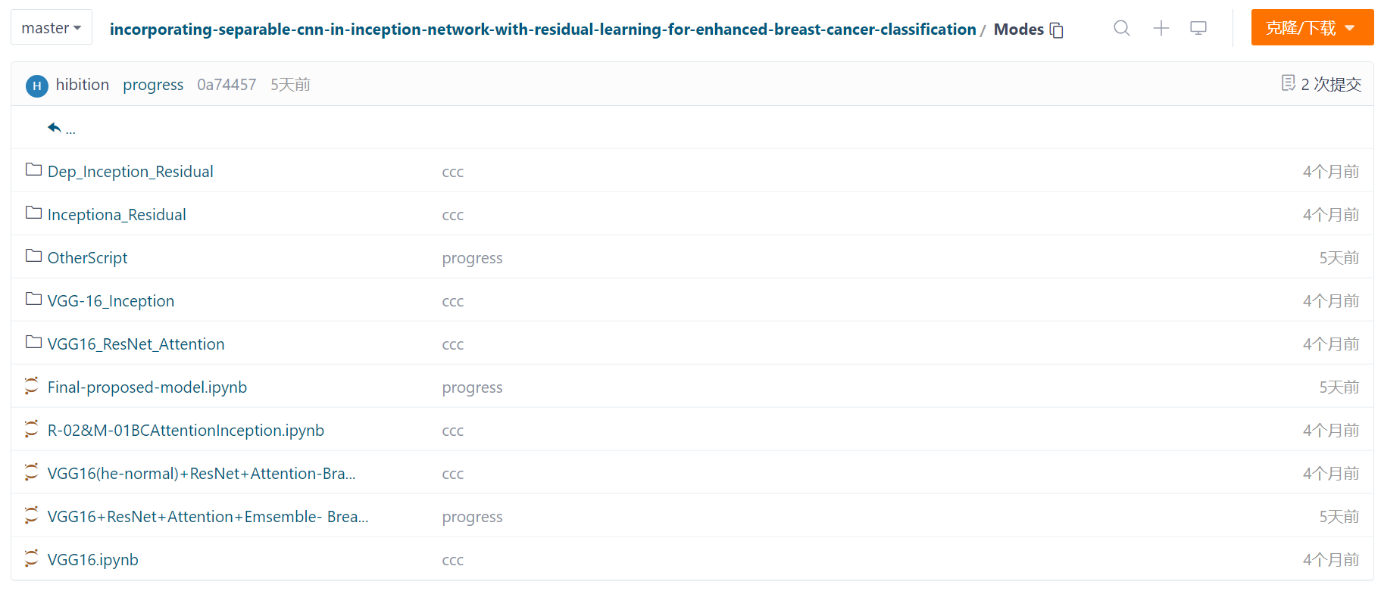

# **Implementation and Results**

## **Implementation**

### **Dataset**

The dataset utilized in this study is the BreaKHis_400X dataset sourced from Kaggle, which comprises histopathological tissue slice images. The dataset consists of 642 images labeled as benign and 1166 images labeled as malignant, making it an imbalanced dataset. This imbalance is particularly relevant in the context of medical image analysis, as it can cause models to focus too much on the majority class, leading to poor performance on minority classes and affecting the model's generalization ability and accuracy. Additionally, unbalanced datasets can result in misleading results and biased model evaluations [21]. In this study, addressing the imbalance in the dataset is a key consideration in the design and implementation of this model. The dataset's composition reflects the real-world scenario where malignant cases are often more prevalent than benign cases, underscoring the importance of developing robust algorithms that can effectively handle such class imbalances.

Therefore, to address the challenge of imbalanced datasets in breast cancer classification, this data augmentation techniques have been implemented. This includes calculate both category size and applying augmentation methods such as rotation, flipping, and zooming to enrich the dataset. The chart blow illustrates the percentage of both category of the dataset (Left is the data before augmentation and right is after).

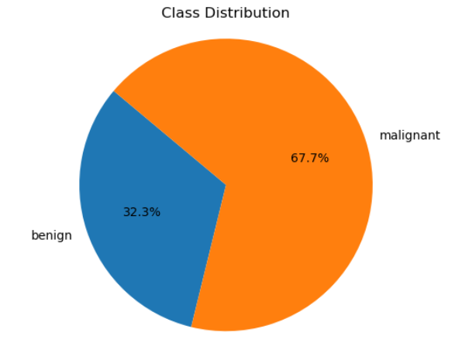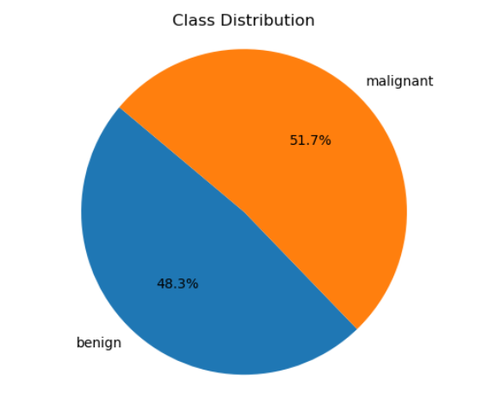

Figure 7: Dataset percentage

### **Model Iteration**

1. ResNet + Inception (First Iteration):

The initial version of the model was crafted by amalgamating the ResNet and Inception architectures to enhance breast cancer classification.

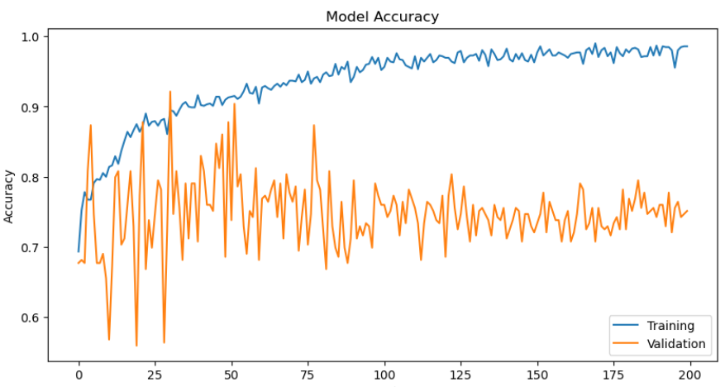 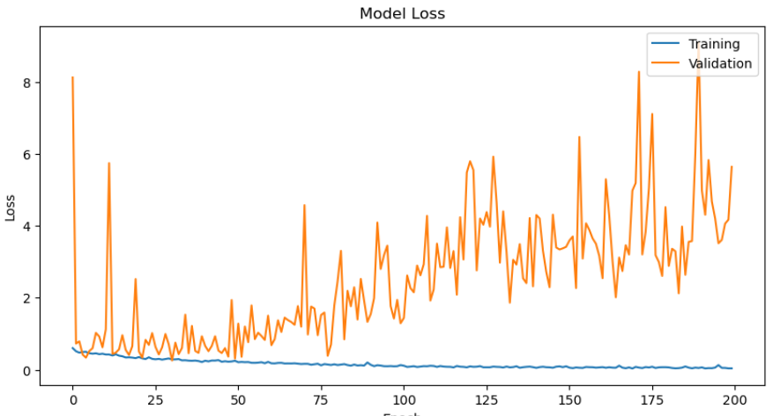

Figure 8: Performance for first version model

While the initial results are not highly satisfactory, achieving an accuracy of 76% and a loss of 1.2, they provide valuable insights into areas that can be enhanced for improvement.

1. VGG16 + ResNet + Attention (Second Iteration):

The second version involves the design of a hybrid model that integrates VGG16, ResNet, and Attention mechanisms to achieve improved feature extraction and classification capabilities.

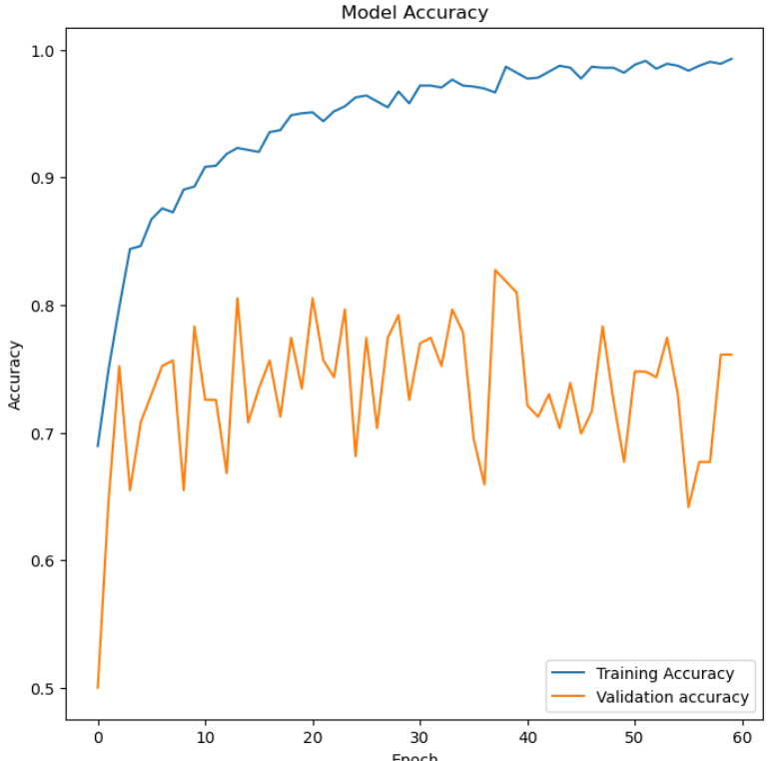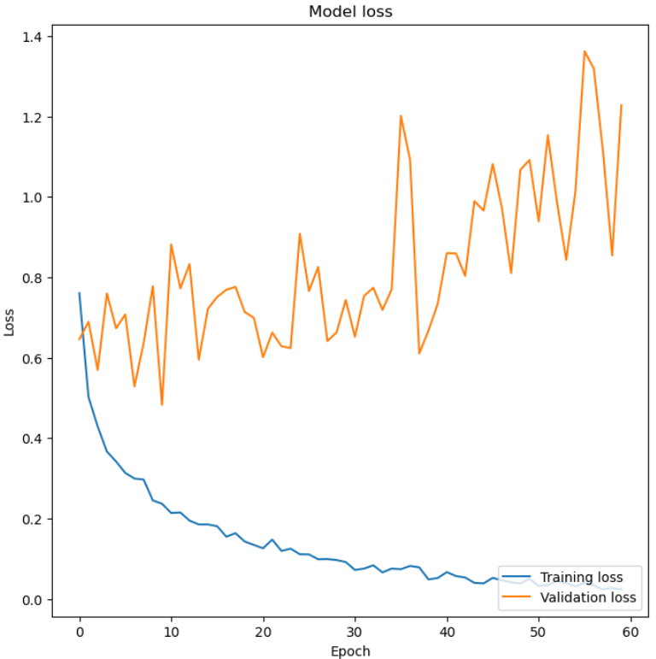

Figure 9: Performance for second version model

Experiments were conducted to assess the performance of the model, and noticeable improvements were observed compared to the first iteration. Specifically, the loss was reduced to less than 1, achieving an accuracy of 0.75.

1. VGG16 + Inception (Third Iteration):

The third version of the model proposes an updated architecture by combining VGG16 and Inception, aiming to improve feature representation capabilities.

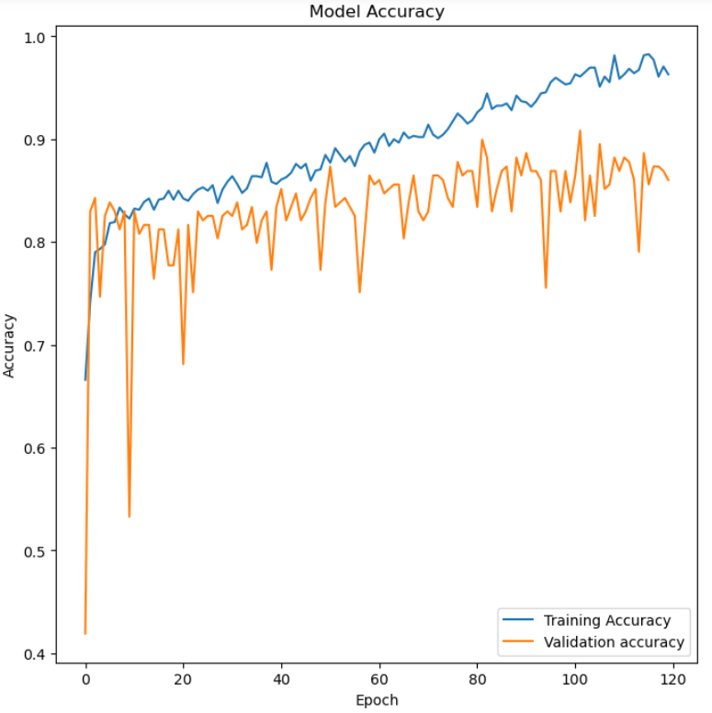 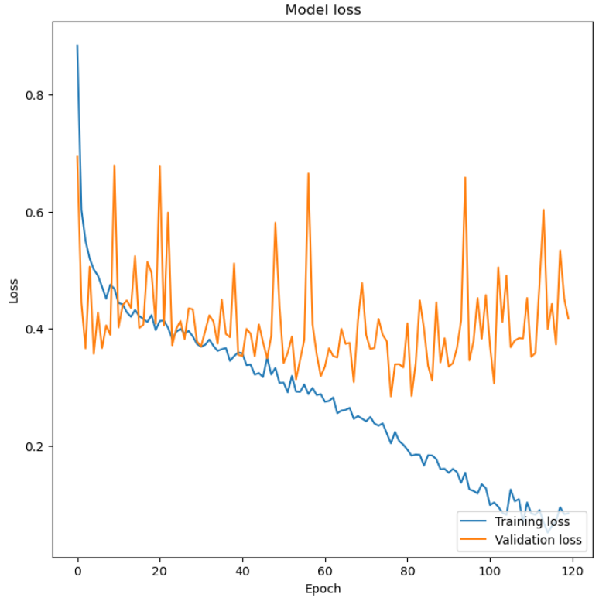

Figure 10: Performance for third version model

Experiments were conducted to assess the effectiveness of this new architecture, resulting in even better performance with a more stable trend. The model achieved an impressive accuracy of 84% with a significantly reduced loss of 0.4.

1. Combining Model (Fourth Iteration):

In the fourth version, insights gained from the three previous model iterations were combined to create a refined model, leveraging the strengths of each. Key optimization steps were implemented, additionally including the introduction of the "he-normal" initialization technique to improve model convergence and training stability.

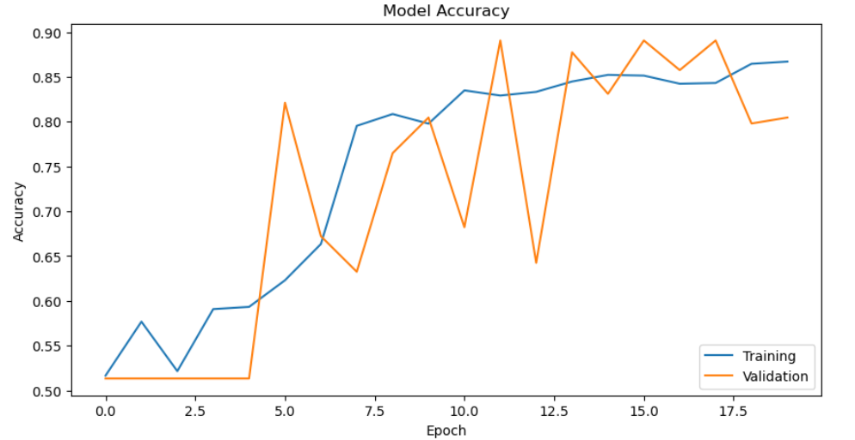 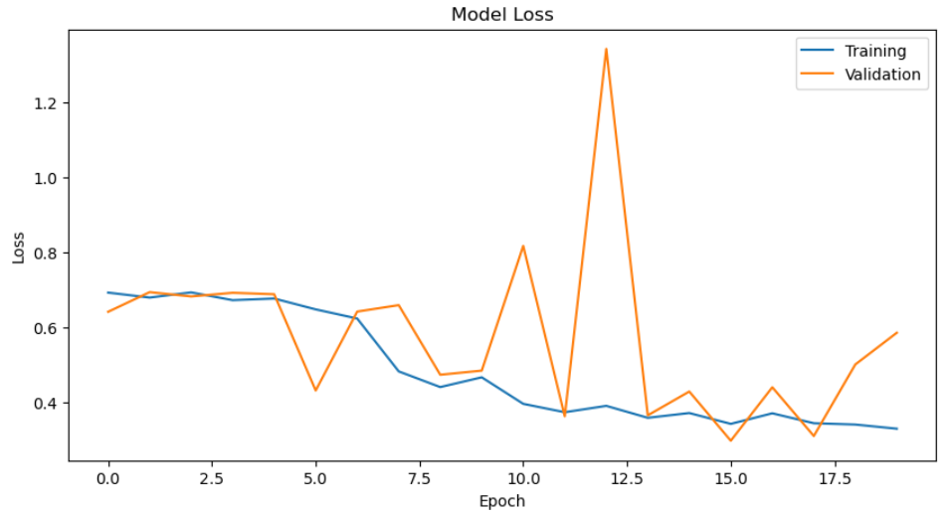

Figure 11: Performance for second version model

The combined model demonstrates significantly improved performance, achieving a loss value of less than 0.4 and an accuracy of 90%. Importantly, the model has not shown signs of overfitting yet, suggesting that the final result may even be better once further optimizations are applied.

## **Results of Final Model Training**

Combining the previously mentioned techniques, after 120 rounds of training and continually fine-turning, proposed model has achieved satisfactory results in terms of accuracy, reaching an accuracy rate of 95%. This high accuracy means that the model can accurately identify potential breast cancer lesions and abnormalities, providing powerful assistance to doctors. The accuracy can be calculated by:

$$Accuracy(A, B)= \frac{1}{n}\sum_{i=0}^{n}{1_{{ (A}_{i}=B_{i})}}$$

Furthermore, the fact that the validation accuracy closely mirrors the training accuracy indicates that proposed model performs well in avoiding overfitting. Overfitting is a common issue in deep learning models, where the model performs well on training data but poorly on test data, demonstrating weak generalization ability. By maintaining consistency between training and validation accuracy, and also exhibiting strong generalization ability on the test set, proposed model can be more reliably applied to real-world medical scenarios.

Lastly, the decrease in loss to approximately 0.1 demonstrates significant progress in optimizing the training process. The formula for loss:

$Loss= -\left(y_{true}*\log\left(y_{pred}\right)+\left(1-y_{true}\right)*\log\left(1-y_{pred}\right)\right)$,

Loss is a crucial metric in machine learning that quantifies the discrepancy between predicted and actual values. Lower loss values indicate that the model can more accurately fit the training data, effectively learning the data's features and patterns, thereby improving the overall performance and reliability of the model.

In summary, after 120 rounds of training, proposed model has made significant improvements and progress in terms of accuracy, overfitting issues, and loss values, providing robust support and assurance for the early diagnosis and treatment of breast cancer. These achievements not only contribute to raising the standard of healthcare but also lay a solid foundation for the future application of deep learning in the medical field.

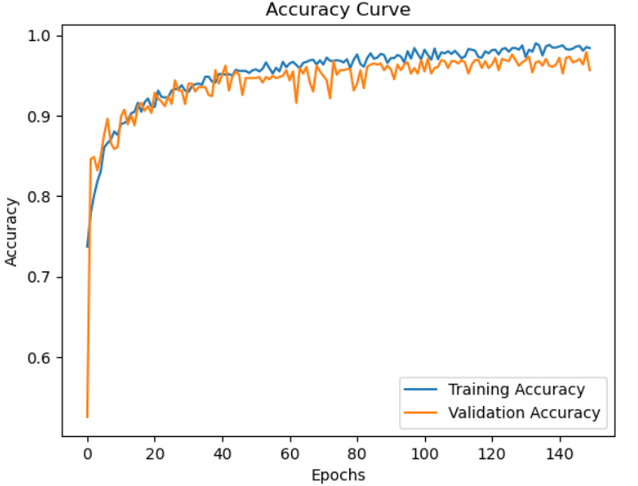 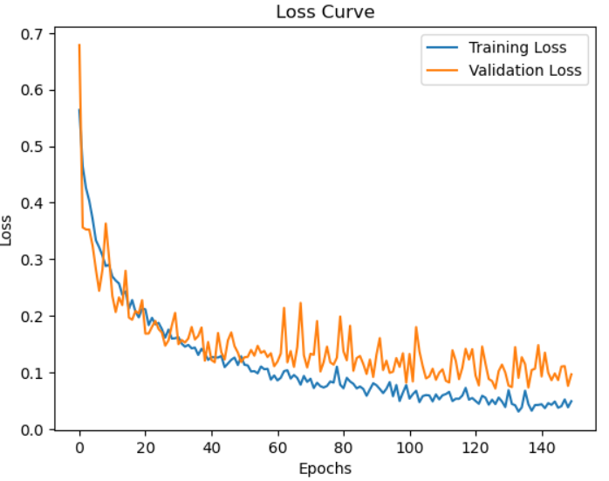

Figure 12: Accuracy (0.952) and Loss (0.11) for Proposed Model

The confusiong matrix reflects the model’s actully performace in classifying breast cancer. Here is the map:

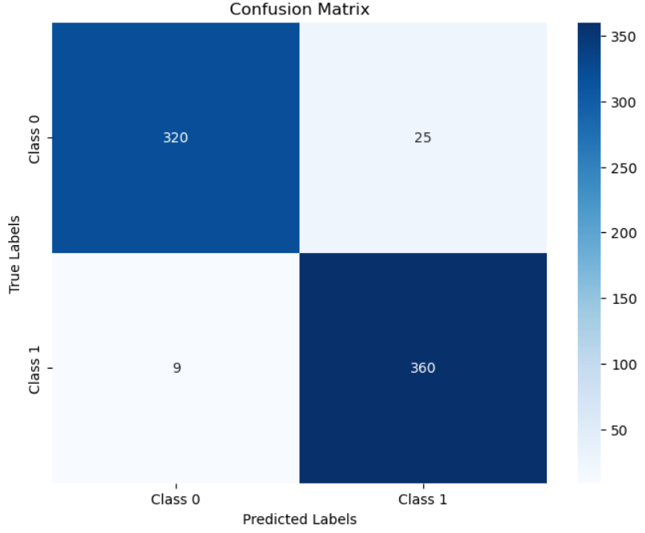

Figure 13： Confusin matrix for Proposed Model

Firstly, for malignant breast cancer tumors (class0), the model predicted 320 cases correctly and 25 cases incorrectly. This indicates that the model performs well in identifying malignant tumors, with a high accuracy rate and a low rate of misclassification.

Secondly, for benign breast tumors (class1), the model predicted 360 cases correctly and 9 cases incorrectly. This also shows that the model has a high accuracy rate and a low misclassification rate in identifying benign tumors.

Overall, the confusion matrix demonstrates the model's good performance in classifying malignant and benign breast cancer tumors, with high accuracy and minimal misclassification. However, for medical diagnostic tasks, especially those involving potentially life-threatening conditions, it is also important to consider the model's sensitivity and specificity to minimize the risks of false positives and false negatives.

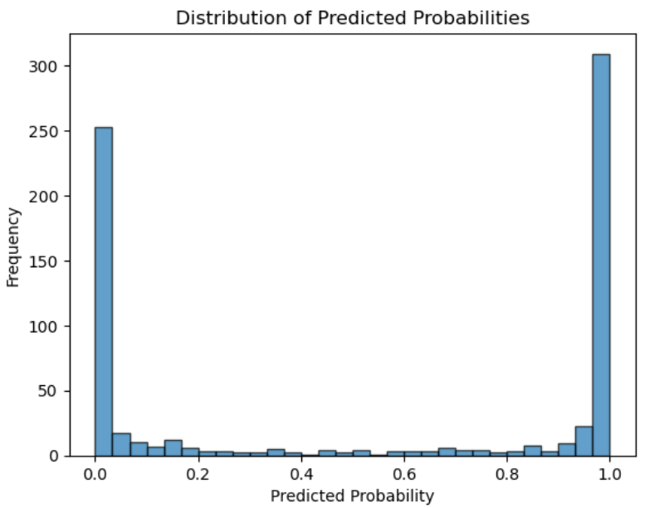

Figure 14: Distribution of Predicted Probabilities

Figure 7 displays the predicted probability distribution of the binary classification model, revealing several noteworthy characteristics. Firstly, it showcases a bimodal distribution, highlighting significant clustering around the probability extremes of 0 and 1. This indicates the model's strong confidence in its predictions, with a clear tendency to assign most instances to either a high or low probability category.

However, this concentrated distribution also raises concerns about potential overfitting. While high confidence can suggest good model performance, an overemphasis on extreme probabilities can sometimes signal overfitting issues. Overfitting occurs when a model becomes overly specialized to the training data, leading to inflated performance metrics on known data but reduced accuracy and generalization on unseen data.

Moreover, the distribution's shape prompts consideration of threshold calibration. The chosen threshold for categorizing probabilities into classes can significantly impact model behavior, especially in critical applications like medical diagnostics. Adjusting the threshold based on domain-specific needs, such as prioritizing minimizing false negatives over false positives, becomes crucial for optimizing model performance.

Additionally, the scarcity of predictions falling within a moderate probability range indicates instances of ambiguity or uncertainty in the model's predictions. While a lack of predictions around 0.5 probability suggests the model seldom struggles with uncertainty, it's essential to assess these ambiguous predictions carefully, as they could represent scenarios where the model's confidence is less reliable.

In conclusion, while the model's confidence-based classification is evident from the distribution, it's imperative to complement these observations with additional validation metrics. Ensuring that the model's predicted confidence aligns with empirical robustness in real-world applications requires thorough evaluation and consideration of factors like overfitting, threshold selection, and uncertainty handling.

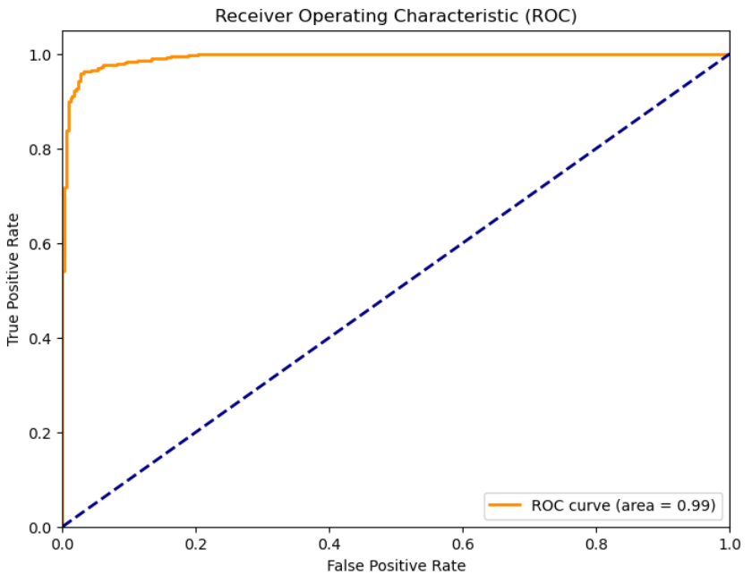

Figure 15: Receiver Operating Characteristic

The Receiver Operating Characteristic (ROC) curve displayed above showcases the performance of the proposed model, boasting an impressive Area Under the Curve (AUC) score of 0.99. This curve is a graphical representation that visually depicts the diagnostic capability of a binary classifier system as it varies its discrimination threshold.

In the context of the ROC curve, True Positive Rate (TPR) is calculated as $TPR=\frac{TP}{TP+FN}$, where TP represents the number of true positive instances and FN signifies the number of false negative instances. Similarly, False Positive Rate (FPR) is computed as $FPR=\frac{FP}{FP+TN}$, where FP denotes the number of false positive instances and TN stands for the number of true negative instances.

In essence, the larger the area under the ROC curve (AUC), the better the model's performance. AUC serves as a standard metric for evaluating and comparing the performance of different models in binary classification tasks.:

Key observations from the ROC curve:

* High AUC: An AUC of 0.99 is exceptionally high, which typically indicates excellent model performance. The closer the AUC is to 1, the better the model is at distinguishing between the two classes.
* Early Rise: The curve rises sharply towards the top-left corner of the plot, which suggests a high true positive rate (sensitivity) at low false positive rates. This rapid ascent indicates that the model has a high probability of correctly identifying positive cases early on without incurring many false positives.
* Threshold Selection: The steepness of the initial rise also implies that there might be a range of thresholds where the model maintains high sensitivity with minimal false positives, which is ideal for many applications, especially in critical fields like medical diagnostics.
* Performance Across Thresholds: Because the curve stays close to the left border and then the top border of the ROC space, this shows that the model performs well across a variety of thresholds.

However, while the ROC curve is indicative of strong performance, it is crucial to consider the context of the model's application. The cost of false positives and false negatives can vary depending on the situation, and the ROC curve alone does not convey this information. Additionally, in situations where classes are highly imbalanced, precision-recall curves may provide a more informative picture of performance. It's also beneficial to look at other metrics and analyze performance on a separate validation set to ensure that the model's high AUC translates to practical efficacy.

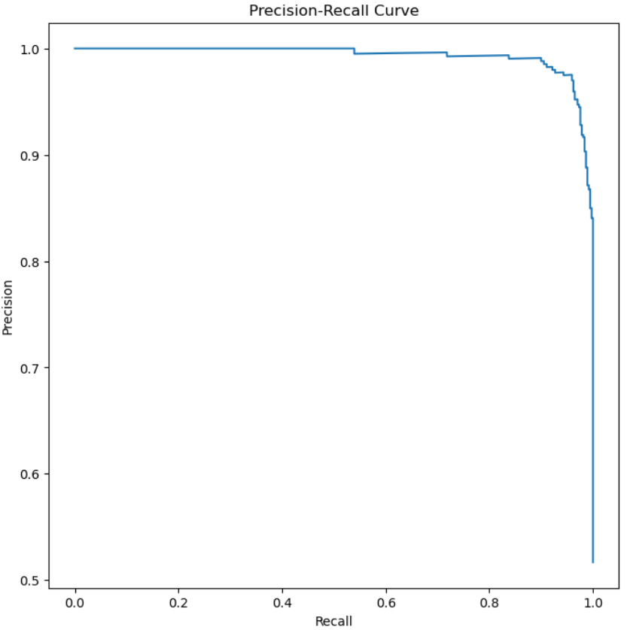

Figure 16: Precision-Recall Curve

The Precision-Recall (PR) curve provided illustrates the model's performance regarding precision, calculated as $Precision= \frac{TP}{TP+FP}$, which represents the ratio of true positives to the sum of true positives and false positives. Additionally, the curve represents recall (also known as sensitivity), computed as $Recall (SE)= \frac{TP}{TP+FN}= \frac{TP}{P}$, where TP is the number of true positive instances, FN is the number of false negative instances, and P represents the total number of positive instances. These metrics are crucial for assessing the model's ability to correctly identify positive instances while minimizing false positives and negatives across various thresholds.

Here are the insights based on the PR curve:

* High Precision: The model maintains a high level of precision across most recall levels. High precision relates to a low false positive rate, which is particularly important in applications where the cost of a false positive is high.
* Slight Decline in Precision: There is a slight decline in precision as recall increases. This is a common trade-off, indicating that as the model tries to capture more positive cases (increasing recall), it makes more mistakes (decreasing precision).
* Stability Across Thresholds: The curve starts at the top right corner and stays flat for a considerable range, suggesting stable precision even as the number of true positives increases.
* Sharp Drop at High Recall: The sharp drop at the end of the curve suggests that precision falls significantly when the model attempts to achieve very high recall. At this point, the model is likely making more false positive errors to capture all true positives.

Overall, this PR curve suggests that the model performs well, especially at the right balance between precision and recall, which is crucial for practical applications. The area under the PR curve would give a quantitative measure of the model's overall performance in this regard.

However, it is important to consider the balance of the classes in the dataset. If the positive class is rare, maintaining high precision can be more challenging, and the PR curve becomes a more critical measure of performance than the ROC curve. Additionally, one should consider the specific requirements of the application for which the model is being developed to choose the optimal operating point on the curve.

Based on the table provided, the " Proposed Model " demonstrates exceptional performance in terms of both loss and accuracy. Specifically, the " Proposed Model " has a loss value of 0.09, significantly lower than other models, indicating its ability to accurately fit the data and learn its features and patterns during training. Additionally, achieving an accuracy of 96.4%, it outperforms all other listed models, showcasing excellent performance in classifying different types of breast cancer tumors. The detailed comparison is presented in the following table:

|  |  |  |
| --- | --- | --- |
| **AI Model** | **Loss** | **Accuracy** |
| InceptionV3 | 0.72 | 69.1 |
| ResNet50 | 0.48 | 80.0 |
| VGG16 | 0.2 | 85.2 |
| ResNet-Inception | 2.0 | 75 |
| VGG16-Inception | 0.56 | 84.2 |
| VGG16-Attention | 1.0 | 71 |
| Proposed Model | 0.09 | 96.4 |

Table 3. Compare with classic models

Compared to other models, the strength of the “Proposed Model” lies in its integration of advanced techniques and effective training strategies, leading to optimal results in the breast cancer tumor classification task. Furthermore, the performance of this model reflects continuous progress and innovation in the design and optimization of deep learning models.

Overall, the outstanding performance of the “Proposed Model” provides strong support and assurance for the early diagnosis and treatment of breast cancer, offering valuable insights and references for the application of deep learning in healthcare.

## **Related work compares**

The Proposed Model performs better on the BreaKHis 400X dataset compared to the traditional models it incorporates. This article will also compare the results obtained with those found in the literature review. Detailed data will be presented in Table 4.

|  |  |  |  |  |  |
| --- | --- | --- | --- | --- | --- |
| **AI Model** | **Recall** | **Precision** | **Sensitivity** | **Specificity** | **Accuracy** |
| DenseNet121 [15] | 66.96 | 57.95 | - | - | 66.96 |
| EfficientNetB5 [15] | 66.83 | 56.55 | - | - | 66.83 |
| SCAE_maxpooling [10] | - | - | - | - | 81.88 |
| SCAE_avg [10] | - | - | - | - | 80.13 |
| DenseNet_with_DFT [11] | - | - | 92.13 | 91.40 | 94.34 |
| ResNet_with_DFT [11] | - | - | 95.26 | 92.75 | 96.03 |
| Wang et. al. [12] |  |  | 94.31 | 93.03 | 93.54 |
| Adeshina et. al [13] |  |  | 76.67 | 63.36 | 91.54 |
| Spanhol et. al [14] |  |  | - | - | 85.10 |
| Proposed Model | 96.81 | 97.43 | 96.80 | 97.74 | 96.49 |

Table 4. Compare with models from different research

The comparison between the Proposed Model and other related works, all utilizing the BreaKHis 400X dataset, can be analyzed and evaluated from several perspectives.

Firstly, in terms of metrics, this Proposed Model demonstrates exceptional performance in Recall, Precision, Sensitivity, Specificity, and Accuracy, significantly outperforming other models in the related works. Specifically, this model achieves a Recall of 96.81%, Precision of 97.43%, Sensitivity of 96.80%, Specificity of 97.74%, and Accuracy of 96.49%. These metrics reflect the high accuracy and reliability of this model in breast cancer diagnosis, effectively distinguishing between malignant and benign breast tumors.

Secondly, regarding the dataset used, this model utilizes the widely recognized and extensively used BreaKHis 400X dataset. This lends credibility and comparability to the experimental results.

Thirdly, from a technical standpoint, this Proposed Model integrates advanced techniques such as VGG16, Inception, ResNet, and attention mechanisms. By leveraging these techniques comprehensively, this model captures image features more effectively, thereby enhancing the accuracy and efficiency of breast cancer diagnosis.

Lastly, in terms of research value and practicality, this Proposed Model has achieved remarkable results in breast cancer diagnosis, demonstrating high clinical utility and potential for widespread application. It contributes positively to improving healthcare standards and enhancing patient treatment outcomes.

In summary, through comparison with other related works, this Proposed Model exhibits superior performance and potential in breast cancer diagnosis, with high research value and practical significance.

## **Model Explainability**

Even though machine learning models remain largely black boxes, their widespread use in daily life and production makes it crucial to understand the mechanisms behind model predictions. Analyzing the interpretability of models not only enhances users' trust in prediction outcomes but also helps designers develop targeted optimization strategies for the models [16].

There are several reasons for choosing attention mechanisms as a means of model interpretability. Firstly, attention mechanisms provide intuitive explanations by assigning a weight to each input token, showcasing the important parts the model focuses on during prediction, making it easier for non-experts to understand. Secondly, attention weights are relatively easy to extract and visualize, aiding researchers and developers in quickly understanding the decision-making process of the model. Additionally, attention mechanisms have been widely used in deep learning models, especially in natural language processing, making it a natural choice to use the existing attention mechanisms of the model for explanation. Finally, attention mechanisms have received extensive research and application in both academia and industry, with many papers and tools specifically exploring attention-based explanations [17].

Therefore, to elucidate the workings of the model, this paper adopts the Grad-CAM (Gradient-weighted Class Activation Mapping) technique. It samples and generates heatmaps after the attention layer to visualize the weights assigned to different regions during the prediction process of the deep learning model. This heatmap reveals which parts or features receive higher weights from the attention block.

Here is the detail operation of Grad-CAM is executed:

1, Forward Propagation: Medical images are fed through the model via forward propagation until reaching the target convolutional layer.

2, Gradient Calculation: Gradients of the target class output with respect to the feature maps of the last convolutional layer are computed.

3, Heatmap Generation:

* Firstly, global average pooling is applied to the gradient values within each channel of the feature map, obtaining importance weights for each channel.
* Next, the weights are multiplied with the corresponding feature map, and the results across all channels are summed to obtain the class activation heatmap.
* Post-processing: The generated heatmap undergoes ReLU activation to remove activations negatively impacting the target class, focusing only on features with positive impact.
* Upsampling: The heatmap is upsampled to match the size of the input image, ensuring alignment with the original image.

The Grad-CAM samples showing in Figure7:

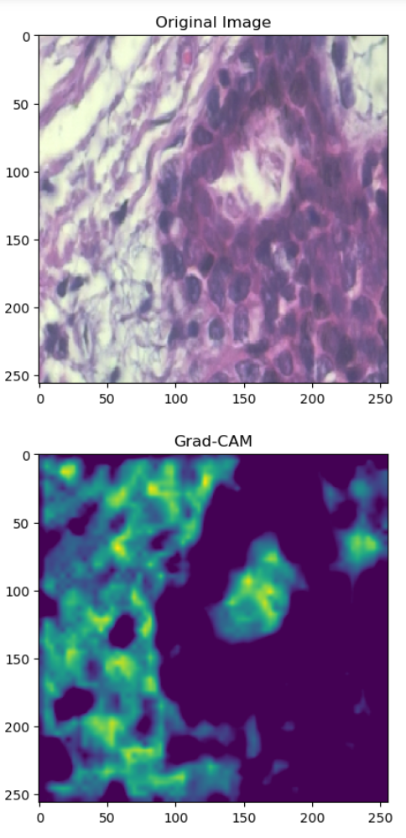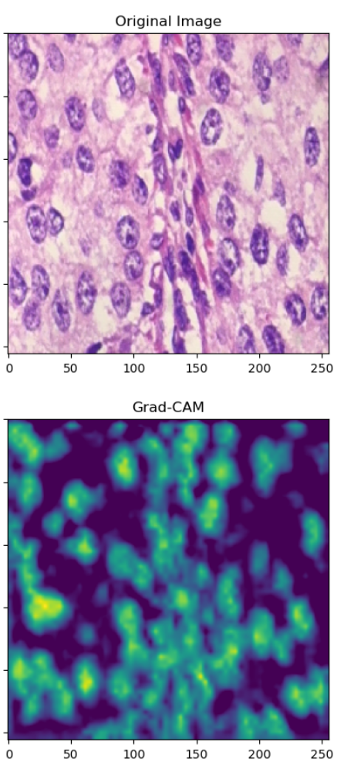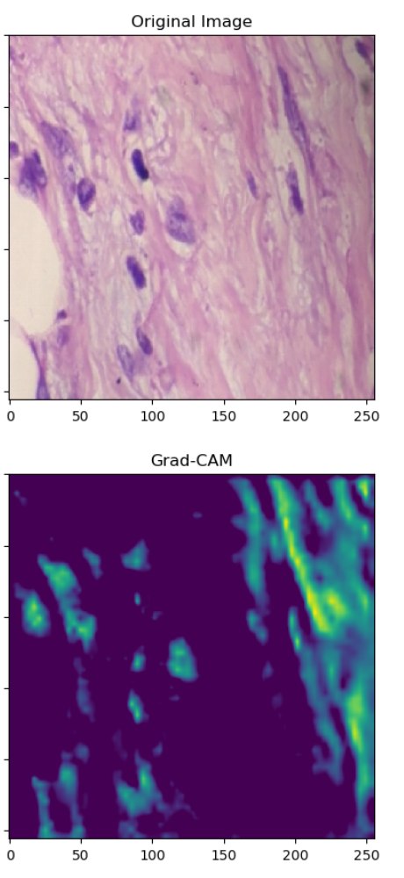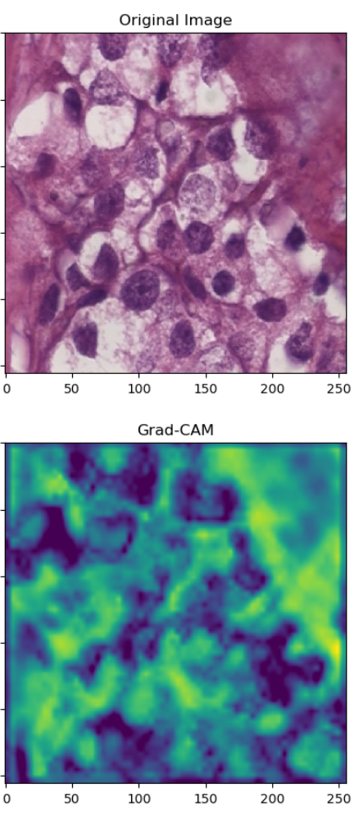

Figure 17： Grad-CAM samples

The first row of images represents the original medical images, which are microscopic breast tissue slices subjected to a special staining process. Each image has its corresponding Grad-CAM heatmap below. In these heatmaps, brighter areas indicate higher attention and weight assigned by the model when identifying the malignancy or benignity of tumor tissue. For instance, yellow and green regions suggest areas crucial for the prediction, while blue and black areas are of lower importance.

Interpreting these heatmaps allows it is easy to infer whether the model focuses on features relevant to breast cancer diagnosis. For example, it reveals that the model pays more attention to irregular cell shapes and places higher emphasis on nuclei, which play a crucial role in cancer.

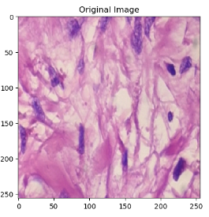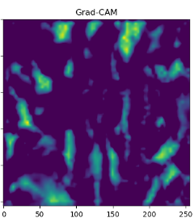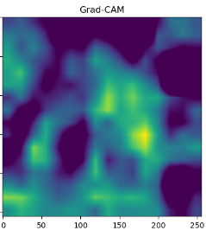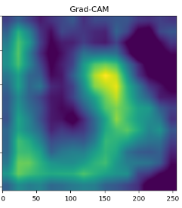

Figure 18: Grad-CAM in different depth (from left to right are shallowest level to deepest level)

The Figure8 shows Grad-CAM visualizations at different depths of a neural network, revealing the gradient weights the model assigns to the original data at varying levels of abstraction:

* Topmost Grad-CAM heatmap: At the shallowest level, the heatmap displays relatively high spatial resolution, pinpointing specific areas the model focuses on. It's apparent that the model seems to be paying attention to dark striated regions, which could represent cellular nuclei, the structure of ducts and lobules, as well as features of the stroma.
* Middle Grad-CAM heatmap: This layer's heatmap is blurrier compared to the top one, yet it still outlines the general areas of focus.
* Bottom Grad-CAM heatmap: At the deeper network layers, broader continuous areas are highlighted, suggesting that through successive convolutions, the model has distilled the original image into more abstract features, which are likely higher-level summaries of the features detected in the earlier layers. Since this deepest layer’s attention map is relatively blurry, it doesn't offer detailed spatial information about specific structures recognized by the model. However, it indicates the model's ability to recognize patterns and shapes at a higher level of abstraction.

Because features captured at these deeper levels are more closely related to abstract patterns rather than precise locations in the original image, it cannot derive the model's principles from this information alone. Nevertheless, this is not inherently negative; for classification tasks, abstract features can be extremely valuable. The deepest layers do not provide detailed insights into the model's interpretations, they play a critical role in the model's ability to generalize and identify broader patterns that are significant for classification.

This visualization of weight distribution demonstrates how the model's predictions are inferred from specific patterns in the data, enhancing the model's transparency. By understanding which features the model prioritizes, researchers and healthcare professionals gain insights into the decision-making process of the deep learning model, making it easier to trust and interpret its predictions.

Moreover, Grad-CAM provides valuable information for model refinement and optimization. By identifying the areas of high attention, researchers can refine the model architecture or focus on collecting more data for those specific regions, thereby improving the model's performance and accuracy.

## **4.4 UI design**

The user interface (UI) of the proposed system plays a crucial role in showcasing the functionality of the deep learning model deployed using Python Flask. The main objective of the website is to demonstrate the model's capability in predicting whether uploaded breast cancer images are benign or malignant. The UI is divided into two main sections for user interaction and result visualization.

1, Homepage



Figure 19： UI interface Homepage

Upon accessing the website, users are greeted with a clean and intuitive homepage. The homepage prominently features two buttons:

* Upload Image: This button allows users to upload breast cancer medical images from their local storage. It provides a seamless experience for users to input their data into the system.
* Start Predict: Once an image is uploaded, users can click this button to initiate the prediction process. This action triggers the model to analyze the uploaded image and provide the prediction results.

2, Prediction Results Presentation

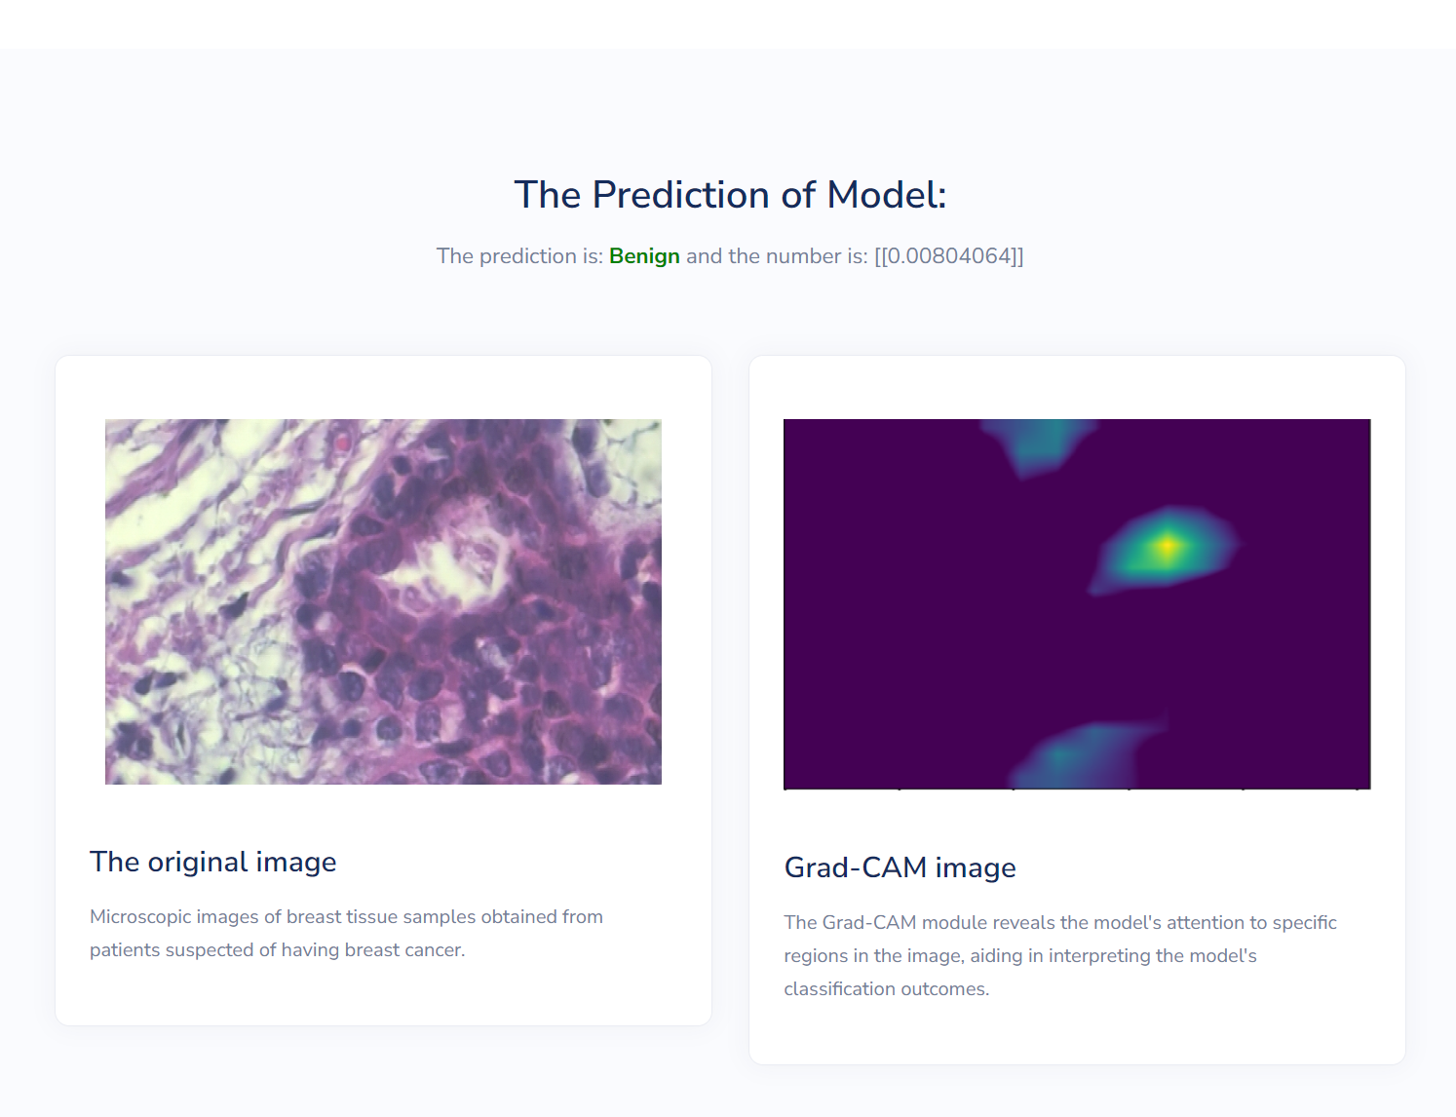

Figure 20： UI interface Result show

After clicking the "Start Predict" button, users are directed to the prediction results section, which consists of three key elements:

* Prediction Result: This element displays the prediction outcome of the deep learning model, indicating whether the uploaded image is classified as benign or malignant. It provides users with immediate feedback on the model's prediction accuracy.
* Original Image: Alongside the prediction result, the original uploaded image is displayed for reference. This allows users to compare the predicted label with the actual content of the image, enhancing transparency and understanding.
* Grad-CAM: To further enhance interpretability, the Grad-CAM visualization is included in this section. It highlights the specific regions of interest within the image that contributed most significantly to the model's prediction. This visual aid helps users comprehend the model's decision-making process.

# **Professional Issues**

## **Project Management**

### **Activities**

State the complete tasks for each objective. The details here can be presented by a table.

|  |  |  |  |  |
| --- | --- | --- | --- | --- |
| Objective | Activities | Start Date | End Date | State |
| Project proposal | 1, Conduct online research on breast cancer.  2, Preliminary model design.  3, Write a project proposal report. | 2023/  10/10 | 2023/  10/26 | Complete |
| Data Collection | 1, Search for breast cancer datasets on Kaggle.  2, Compare and evaluate available datasets.  3, Download selected datasets. | 2023/  10/16 | 2023/  10/30 | Complete |
| Data Preprocessing | 1, Analyze the structure of the chosen dataset.  2, Write preprocessing code (including data classification, removal of outliers, standardization of naming conventions, and data augmentation). | 2023/  11/1 | 2023/  11/7 | Complete |
| Model Design | 1, Research and study relevant papers.  2, Design the structure of the deep learning model.  3, Implement the designed model. | 2023/  11/7 | 2023/  11/19 | Complete |
| Model Training | Train the deep learning model using various permutations and combinations of the dataset. | 2023/  11/19 | 2023/  12/2 | Complete |
| Progress Report | 1, Read and analyze relevant research papers.  2, Summarize the current progress and assess the model's performance. | 2023/  12/10 | 2023/  12/22 | Complete |
| Model Evaluate | 1, Continue reading relevant papers and integrating additional techniques.  2, Experiment with different parameters to optimize the model. | 2023/  12/26 | 2024/  3/12 | Complete |
| Comparation and Analysis | 1, Design and write test code to evaluate model performance. Includes accuracy, Loss, F1-score, and other relevant indicators.  Generate prediction distributions and Grad-CAM visualizations for analysis.  2, Identify areas for improvement based on the analysis results. Implement targeted improvements to enhance model effectiveness and accuracy. | 2024/  3/12 | 2024/  3/24 | Complete |
| UI Interface Development | 1, Create UML diagrams for the website.  2, Design the layout and user interface of the website.  3, Implement the website interface. | 2024/  3/21 | 2024/  4/1 | Complete |
| Final Report | 1, Read and analyze relevant research papers. Compare the result of it.  2, Summarize the model result and assess the model's structure.  3, Organize the research process and record and summarize risks | 2024/  4/1 | 2024/  4/15 |  |
| Poster and Presentation | 1, Create Presentation Slides  2, Record UI interface video  3, Draw poster to show some overlook of this research. | 2024/  4/1 |  |  |

Table 5： Activities of objects

### **Schedule**

The project schedule utilized with the design of Gantt is presented in Figure 4.

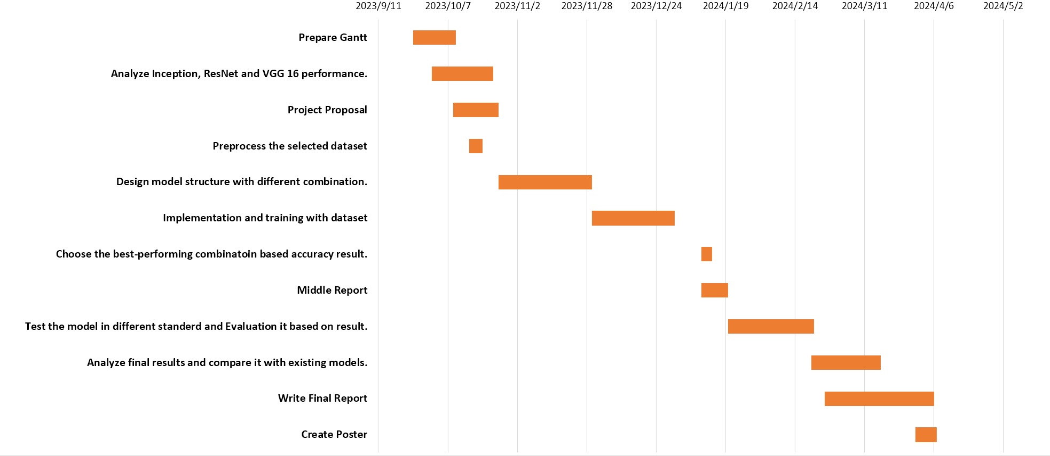

Figure 21: The project schedule Gantt

### **Project Data Management**

The Gitee platform would be used as the data management plan for this project codes to control the project version. The Git URL will be present here: <https://gitee.com/hibition/incorporating-separable-cnn-in-inception-network-with-residual-learning-for-enhanced-breast-cancer-classification.git>

In addition, NAS (Network Attached Storage) is also used as the manage method of some documents. The server which run the NAS interface and Hard Disk Drive was present in school.

The data management plan will be showed on the table below:

|  |  |
| --- | --- |
| Data | Management method |
| Ethics forms | Document files in NAS |
| Weekly report | Document files in NAS |
| Report | Document files in NAS |
| Project codes | In Gitee platform |
| Testing and Analysis | In Gitee platform |

Table 6： Management methods of Data

### **Project Deliverables**

Project proposal, Project progress report, Final report, Presentation Slide, project code, ethics-form, reference, UI design and weekly report.

## **Risk Analysis**

1. Risk Analysis and Mitigation

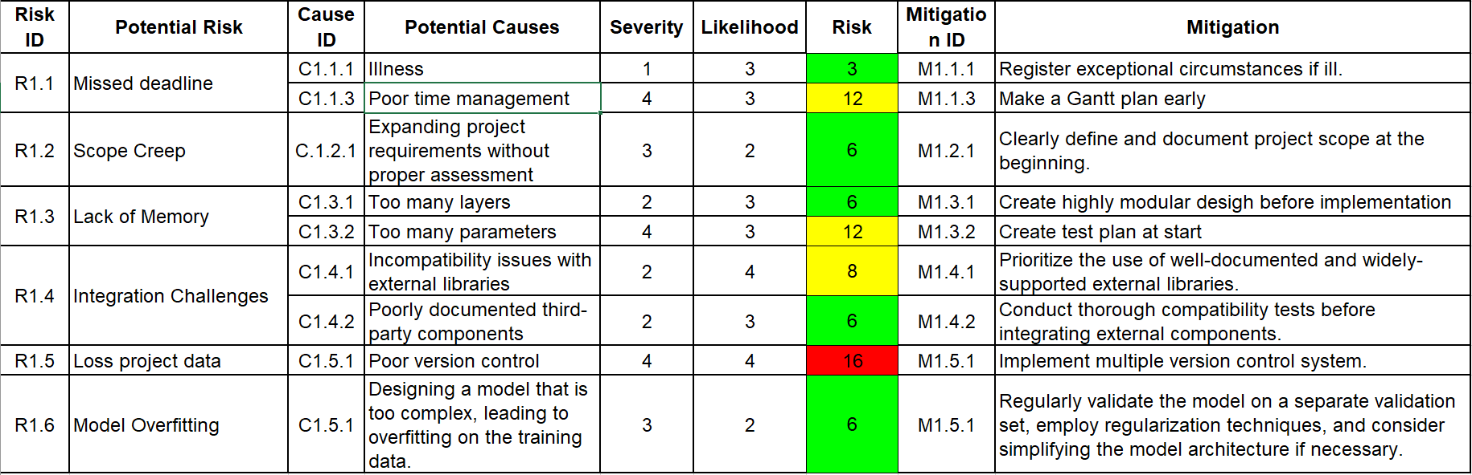

Table 7: The Risk

## **Professional Issues**

### Legal Issues

1. Intellectual Property Rights:

Code and Algorithm Licensing: Ensure that the software code and algorithms used in the project do not infringe on any existing copyrights or patents.

Usage of Datasets: If datasets used for training the GAN models are protected by intellectual property laws, obtaining proper permissions or licenses is essential.

1. Data Protection and Privacy Laws:

Sensitive Data Handling: If the datasets include sensitive information, such as healthcare data, additional legal safeguards must be in place.

Data Security Measures: Implementing robust security protocols to prevent unauthorized access or breaches of the datasets used.

1. Regulatory Compliance:

Export Controls: Ensuring the technology developed does not fall under export control regulations, particularly if it involves dual-use technology.

Healthcare Regulations: If the project's application extends to healthcare, compliance with relevant healthcare regulations and standards is necessary.

Surveillance Laws: In applications related to surveillance, adherence to laws governing surveillance and privacy rights is crucial.

### Social Issues

1. User Privacy and Security:

Respect for Privacy: The use of super-resolution in surveillance must respect individual privacy rights.

Data Anonymization: Ensuring that any personal data used in the project is anonymized to protect individual identities.

Security of Enhanced Images: Ensuring that the high-resolution images generated are not misused for unethical surveillance or privacy breaches.

1. Impact on Public Perception:

Misinformation and Deepfakes: Addressing the potential use of super-resolution technology in creating misleading or fake images.

Public Trust: Maintaining public trust by transparently communicating the intended use and limitations of the technology.

Educational Outreach: Providing educational resources about technology to mitigate misunderstanding and fear.

### Ethical Issues

1. Research Integrity:

Avoidance of Plagiarism: Ensuring that all research sources are accurately cited and acknowledged.

Data Falsification: Avoiding any falsification or manipulation of research data, including image datasets.

Transparency in Methodology: Full disclosure of the methodologies, algorithms, and processes used in the project.

1. Informed Consent and Participation:

Consent for Data Use: If using human-derived data, obtaining informed consent from participants is essential.

Ethical Use of Data: Ensuring that the data is used ethically and in a manner that respects the rights and privacy of individuals.

Ethical Review Process: Submitting the project for ethical review if it involves human participants, as per university and professional guidelines.

### Environmental Issues

1. Energy Consumption:

Resource Efficiency: Optimizing the model to minimize energy consumption during training and inference.

Green Computing Practices: Adopting sustainable practices in computing resources, like using energy-efficient hardware.

Carbon Footprint: Assessing and trying to minimize the carbon footprint of the computational resources used for the project.

# **Conclusion**

The culmination of this project has yielded significant achievements in the realm of breast cancer classification using deep learning techniques. The primary goal was to develop a deep learning model that integrates VGG16, Inception, ResNet, and an attention mechanism to enhance the accuracy and efficiency of diagnosing breast cancer from histopathological images. This model, termed the "Proposed Model," has demonstrated remarkable performance, achieving an accuracy rate of 95% and outperforming traditional methods and existing models in the literature.

## What Was Achieved:

Data Collection and Preprocessing: The BreaKHis_400X dataset from Kaggle was successfully utilized, with robust preprocessing techniques applied to ensure data integrity and optimal model training. Data augmentation strategies were implemented to address dataset imbalances, enriching the diversity of training data.

Model Architecture and Training: The integration of VGG16, Inception, and ResNet with an attention mechanism resulted in a sophisticated model architecture. The model was trained effectively using various optimizers and epochs, with the "He-normal" initialization method ensuring stable and efficient training.

Performance Evaluation: The Proposed Model was rigorously evaluated using accuracy, precision, recall, F1 score, and other relevant metrics. The model exhibited high sensitivity and specificity, crucial for medical diagnostic tasks, and a confusion matrix revealed its strong performance in classifying malignant and benign breast cancer tumors.

Comparative Analysis: The Proposed Model was benchmarked against several state-of-the-art models, showcasing its superiority in terms of recall, precision, sensitivity, specificity, and accuracy. This comparative analysis validated the model's potential as a reliable diagnostic tool in the medical domain.

Interpretability and UI Design: Efforts were made to enhance the model's interpretability through mathematical formulations and visualization techniques like Grad-CAM. A user-friendly UI was designed to demonstrate the model's predictive capabilities, making it accessible for potential end-users.

## Limitations:

Despite the noteworthy achievements of the Proposed Model in breast cancer classification, several limitations must be acknowledged and addressed in future work. Firstly, the reliance on a singular dataset, while effectively demonstrating the model's capabilities, raises concerns regarding the diversity and breadth of the training data. The BreaKHis_400X dataset, although substantial, may not encompass the full spectrum of histopathological variability seen in breast cancer subtypes across different populations.

Secondly, the model's performance, albeit high, has not been evaluated in a clinical setting, and thus its real-world efficacy remains to be proven. The transition from image classification to clinical application involves numerous variables that may affect performance, including interobserver variability and the complexity of integrating AI tools into existing medical workflows.

Thirdly, the current model does not account for incremental learning or adaptability to new data over time, which is essential for maintaining accuracy as new diagnostic methods and treatments emerge. In the fast-evolving field of medical diagnostics, the model's long-term relevance depends on its ability to learn from new patterns and data.

Additionally, the computational demands of the Proposed Model, primarily due to its complex architecture integrating multiple frameworks and an attention mechanism, may pose challenges for deployment in settings with limited resources. Optimization for computational efficiency without compromising accuracy is a critical consideration for scalability and accessibility.

Lastly, the ethical considerations surrounding the deployment of AI in healthcare, particularly regarding algorithmic transparency and the potential for biases inherent in training data, have not been fully explored. It is crucial for such models to undergo rigorous ethical evaluation to prevent the perpetuation of existing disparities in medical care.

## Potential Future Work:

Model Optimization: While the Proposed Model has achieved high accuracy, there is always room for optimization. Future work could involve refining the model's architecture, exploring advanced optimization algorithms, and experimenting with different data augmentation techniques to further improve performance

Cross-Dataset Validation: To enhance the model's generalizability, future work could involve testing it on additional datasets, including those from different geographical regions or with varying imaging techniques. This would ensure the model's robustness across diverse medical contexts.

Clinical Trials and Validation: Collaborating with healthcare institutions to conduct clinical trials and validate the model's performance in real-world scenarios is crucial. This would provide valuable insights into the model's practicality and potential for integration into healthcare systems.

Integration with Electronic Health Records (EHR): Future development could focus on integrating the Proposed Model with EHR systems, automating the diagnostic process and providing immediate insights to medical professionals.

Ethical and Legal Considerations: As the model advances towards practical application, addressing ethical and legal challenges, such as data privacy, informed consent, and compliance with healthcare regulations, will be essential.

Educational Outreach and Public Awareness: To foster trust and understanding, future work could include educational initiatives to inform the public about the benefits and limitations of AI in medical diagnostics.

In conclusion, this project has made a contribution to the field of AI-assisted medical diagnosis by developing a highly accurate deep learning model for breast cancer classification. The success of the proposed model lays the foundation for further research and development in this area. It is believed that early detection of the disease through such models can significantly reduce resource wastage and improve patient survival rates [20].

# **References**

1. C. R. Prasad, B. Arun, S. Amulya, P. Abboju, S. Kollem and S. Yalabaka, "Breast Cancer Classification using CNN with Transfer Learning Models," 2023 International Conference for Advancement in Technology (ICONAT), Goa, India, 2023, pp. 1-5, doi: 10.1109/ICONAT57137.2023.10080148.
2. P. K. Samanta, N. K. Rout and G. Panda, "A novel deep CNN model for improved breast cancer detection using ultrasound images," 2023 International Conference on Communication, Circuits, and Systems (IC3S), BHUBANESWAR, India, 2023, pp. 1-4, doi: 10.1109/IC3S57698.2023.10169383.
3. M. Karatayev, S. Khalyk, S. Adai, M. -H. Lee and M. F. Demirci, "Breast cancer histopathology image classification using CNN," 2021 16th International Conference on Electronics Computer and Computation (ICECCO), Kaskelen, Kazakhstan, 2021, pp. 1-5, doi: 10.1109/ICECCO53203.2021.9663757.
4. M. Karatayev, S. Khalyk, S. Adai, M. -H. Lee and M. F. Demirci, "Breast cancer histopathology image classification using CNN," 2021 16th International Conference on Electronics Computer and Computation (ICECCO), Kaskelen, Kazakhstan, 2021, pp. 1-5, doi: 10.1109/ICECCO53203.2021.9663757.
5. P. K. Samanta, N. K. Rout and G. Panda, "A novel deep CNN model for improved breast cancer detection using ultrasound images," 2023 International Conference on Communication, Circuits, and Systems (IC3S), BHUBANESWAR, India, 2023, pp. 1-4, doi: 10.1109/IC3S57698.2023.10169383.
6. M. Ronald, A. Poulose and D. S. Han, "iSPLInception: An Inception-ResNet Deep Learning Architecture for Human Activity Recognition," in IEEE Access, vol. 9, pp. 68985-69001, 2021, doi: 10.1109/ACCESS.2021.3078184.
7. F. Parvin and M. A. Mehedi Hasan, "A Comparative Study of Different Types of Convolutional Neural Networks for Breast Cancer Histopathological Image Classification," 2020 IEEE Region 10 Symposium (TENSYMP), Dhaka, Bangladesh, 2020, pp. 945-948, doi: 10.1109/TENSYMP50017.2020.9230787.
8. K. He, X. Zhang, S. Ren, and J. Sun, “Deep Residual Learning for Image Recognition,” *arXiv (Cornell University)*, Dec. 2015, doi: <https://doi.org/10.48550/arxiv.1512.03385>.
9. S Woo, J Park, J Y Lee et al., "CBAM: Convolutional block attention module[C]", Proceedings of the European conference on computer vision (ECCV), pp. 3-19, 2018.
10. Haryoko, E. Seniwati, T. B. Sasongko, A. Lukman and F. A. Gunawan, "Stacked Convolutional Autoencoder (SCAE) for Breast Cancer Classification," 2023 International Conference on Informatics, Multimedia, Cyber and Informations System (ICIMCIS), Jakarta Selatan, Indonesia, 2023, pp. 410-414, doi: 10.1109/ICIMCIS60089.2023.10349046.
11. A. A. Adeniyi and S. A. Adeshina, "Automatic Classification of Breast Cancer Histopathological Images Based on a Discriminatively Fine-Tuned Deep Learning Model," 2021 1st International Conference on Multidisciplinary Engineering and Applied Science (ICMEAS), Abuja, Nigeria, 2021, pp. 1-5, doi: 10.1109/ICMEAS52683.2021.9692303.
12. P. Wang, J. Wing, Y. Li, P. Li, L. Li and M. Jiang, "Automatic Classification of Breast cancer histopathology images based on deep fusion and enhanced routing", Elsevier:Biomedical Signal Processing and Control, no. 65, 2021.
13. S. A. Adeshina, A. P. Adedigba, A. A. Adeniyi and A. M. Aibinu, "Breast Cancer Histopathology Image Classification with Deep Convolutional Neural Networks," 2018 14th International Conference on Electronics Computer and Computation (ICECCO), Kaskelen, Kazakhstan, 2018, pp. 206-212, doi: 10.1109/ICECCO.2018.8634690.
14. F. A. Spanhol, L. S. Oliveira, C. Petitjean and L. Heutte, "Breast cancer histopathological image classification using Convolutional Neural Networks," 2016 International Joint Conference on Neural Networks (IJCNN), Vancouver, BC, Canada, 2016, pp. 2560-2567, doi: 10.1109/IJCNN.2016.7727519.
15. A. Gautam and S. K. Singh, " Analysis of Deep Learning Models to Detect Breast Cancer from Histopathology Images," TENCON 2023 - 2023 IEEE Region 10 Conference (TENCON), Chiang Mai, Thailand, 2023, pp. 438-443, doi: 10.1109/TENCON58879.2023.10322406.
16. Marco Tulio Ribeiro, Sameer Singh, and Carlos Guestrin. 2016. "Why Should I Trust You?": Explaining the Predictions of Any Classifier. In Proceedings of the 22nd ACM SIGKDD International Conference on Knowledge Discovery and Data Mining (KDD '16). Association for Computing Machinery, New York, NY, USA, 1135–1144. <https://doi.org/10.1145/2939672.2939778>
17. Jasmijn Bastings, Katja Filippova. “The elephant in the interpretability room: Why use attention as explanation when we have saliency methods?” 2020. Proceedings of the 2020 EMNLP Workshop BlackboxNLP: Analyzing and Interpreting Neural Networks for NLP, arXiv:2010.05607, <https://doi.org/10.48550/arXiv.2010.05607>
18. Z. Zheng, H. Zhang, X. Li, S. Liu and Y. Teng, "ResNet-Based Model for Cancer Detection," 2021 IEEE International Conference on Consumer Electronics and Computer Engineering (ICCECE), Guangzhou, China, 2021, pp. 325-328, doi: 10.1109/ICCECE51280.2021.9342346.
19. S. Maleki and H. Izadkhah, "Optimizing GoogleNet using New Connections and Auxiliary Layers Information," 2022 8th Iranian Conference on Signal Processing and Intelligent Systems (ICSPIS), Behshahr, Iran, Islamic Republic of, 2022, pp. 1-6, doi: 10.1109/ICSPIS56952.2022.10043963.
20. R. Uplenchwar, P. Gajbhiye, A. Rathi, S. Shaha, A. Sonawane and A. Marathe, "Breast Cancer Classification," 2022 International Conference on Futuristic Technologies (INCOFT), Belgaum, India, 2022, pp. 1-6, doi: 10.1109/INCOFT55651.2022.10094464.
21. M. Misdram et al., "Analysis of Imputation Methods of Small and Unbalanced Datasets in Classifications using Naïve Bayes and Particle Swarm Optimization," 2020 International Seminar on Application for Technology of Information and Communication (iSemantic), Semarang, Indonesia, 2020, pp. 115-119, doi: 10.1109/iSemantic50169.2020.9234225.
22. Szegedy, C., Liu, W., Jia, Y., Sermanet, P., Reed, S., Anguelov, D., Erhan, D., Vanhoucke, V., & Rabinovich, A. (2014). “Going Deeper with Convolutions.” arXiv (Cornell University). <https://doi.org/10.48550/arxiv.1409.4842>
23. He, K., Zhang, X., Ren, S., & Sun, J. (2015). “Deep residual learning for image recognition.” arXiv (Cornell University). https://doi.org/10.48550/arxiv.1512.03385